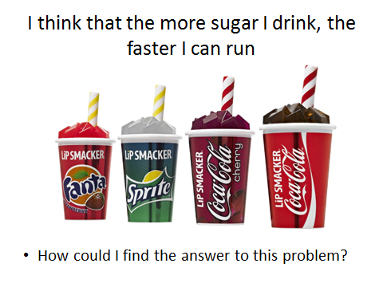

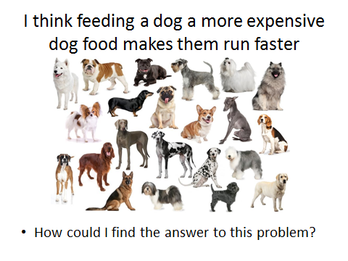

**VARIABLES**

* A variable is anything in an experiment that can change
* A good scientist designs an experiment to have:
  + 1 **independent variable** – the part of the experiment that will be changed on purpose
  + 1 **dependent variable** – the part of the experiment that will be measured after the independent variable has changed
  + LOTS of **controlled variables** – no other variables should be changed. This makes sure the independent variable is responsible for any changes to the dependent.

What are the **independent, dependent and two controlled** variables for the following experiments?

1. Which dog breed is the fastest at playing fetch?

*Hint: The variables are time, dog breed, throw distance, type of ball*

IV: _________________ DV: _________________ CV: _________________

_________________

1. Is an eski or cooler bag better at stopping ice from melting?

*Hint: The variables are type of container, amount of ice added, size of container, time for ice to melt*

IV: _________________ DV: _________________ CV: _________________

_________________

1. Which TV channel plays the most adverts?

IV: _________________ DV: _________________ CV: _________________

_________________

1. How does the daily maximum temperature affect how much water people drink?

IV: _________________ DV: _________________ CV: _________________

_________________

1. How much coke drunk in one hour will make you feel ill?

IV: _________________ DV: _________________ CV: _________________

_________________

Challenge: For experiment 5, how would you know that it was the coke that was responsible for making you feel sick and not just because of how much liquid you drank? How could you adjust your experiment to be sure?